Why Connect Groups?  We’re on a mission to develop transformative group work that our service users and team can connect into, helping us all to reach our potential in mind, body and spirit.  We believe that by connecting staff, volunteers, services users and partners together towards this goal, we will enrich, innovate and multiply our group work, helping us to double our impact in people’s lives.  How will we accomplish this?  We have developed the Authentic Human Connection (AHC) accredited training, to grow our skills at facilitating group work and encourage peer learning.  We have a growing network of Connect Facilitators who have undertaken the training, who can share ideas and resources through their Teams Channel, and can join AHC Celebrations and Connect Group Forums throughout the year.  We have developed a webpage www.oneymca.org/connect to showcase our accredited Connect groups; inspiring collaboration and multiplication internally, and helping us to attract volunteers, partners, and funding externally.  What does becoming an accredited Connect Group involve?  At least one of the group facilitators becoming accredited in AHC  A Group Planner completed as part of the course, to demonstrate how the group fosters AHC, and to give information for the Connect webpage  Attendance figures shared quarterly for Project Connect’s KPIs, along with any updates for the website annually (e.g. impact measurement)  We recommend the use of the Connect Star as part of your impact measurement, but this is not essential as we understand every group is different. | Internal Groups 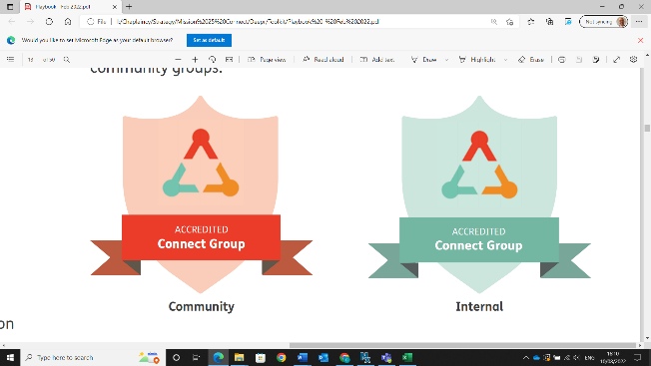  Internal Connect Groups are for staff and volunteers to meet one another from across the charity, and enjoy an activity together. For example, people could meet around music, singing, exercise, prayer, learning, creativity, or simply have fun at a social together!  Community Groups  Community Connect Groups are for our service users and customers – and can range from youth groups to mums & tots, arts & crafts to walking, full body workouts to café drop-ins, prayer groups to therapeutic courses.  Enriching existing groups  You will gain the Connect Accreditation for your group as a kitemark of quality.  The training and peer learning is all designed to help you reflect on your practice, and our experience is that Connect Facilitators have always found new ways of enriching their groups through this process, both in big and in small ways.  We do not require any explicit changes to the way in which you run or advertise your existing group; many groups across One YMCA already operate with a high level of expertise and impact.  Multiplying and innovating new groups  As we have raised the profile of our fantastic group work we have already seen groups begin to spread across different sites and departments.  We have also found that the relational networks have been a catalyst for departments to work together in innovating new groups to meet the needs of their communities.  If you are exploring setting up a new group, we can help you to set up a Connect Forum to meet others who share your interest, link you to a coach who can help you to plan and pilot the new group, and would encourage you to consider applying for the Annual Innovation Prize organised by Team Us.

